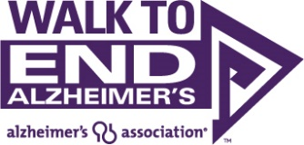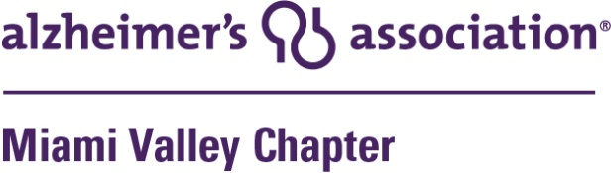
FOR IMMEDIATE RELEASE
Media Contact
Patricia Carroll, Communications Manager
937.610.7007, office; 317.439.7919, cell
plcarroll@alz.org; www.alz.org
Kathy Harper of Premier Health and Pam Thomas of Pickrel, Schaeffer & Ebeling Named Co-Chairs for the 2022 Dayton Walk to End Alzheimer’s
DAYTON, OHꟷApril 18, 2022ꟷKathy Harper of Premier Health and Pam Thomas of Pickrel, Schaeffer & Ebeling will lead the community’s efforts to raise money to support Alzheimer’s care, support and research as the co-chairs of the 2022 Dayton Walk to End Alzheimer’s. The event will be held on Saturday, Oct. 8 at Day Air Ballpark.

The event raises money for research and allows the Alzheimer’s Association Miami Valley Chapter to provide free educational programs, care consultations and support services to local families. This year’s goal is to raise $510,000.

Kathy Harper, Premier Health system vice president, chief marketing and communications officer, said, "I am honored to serve as co-chair of the Dayton Walk. Alzheimer’s and dementia have taken the memories and lives of too many of those we love. My hope is that we can create awareness and action so we can one day rid the world of this devastating disease."

At 10 a.m. the Promise Garden ceremony, a mission-focused experience that signifies solidarity in the fight against the disease will begin. The colors displayed in the Promise Garden flowers represent people’s connection to Alzheimer’s — their personal reasons to end the disease. The Walk will immediately follow the ceremony.

"I am honored to serve as co-chair for the 2022 Dayton Walk to End Alzheimer’s. This disease is devastating for the patient and their family and friends,” said Pam Thomas, marketing director at Pickrel, Schaeffer & Ebeling. “Progress has been made, but there is much more to do. I hope to bring awareness and support to the families and a cure for the patient, so this horrific disease can someday be a distant memory. "

Area residents can go to alz.org/walkmiamivalley to register a team, join an existing team or register to walk as an individual. Participants are encouraged to download the Walk to End Alzheimer’s mobile app to make their experience easier.

“The Dayton Walk is a wonderful day for the community as well as caregivers, families and loved ones who are impacted by Alzheimer's or dementia,'' said Karen Carter, vice president of development for the Alzheimer’s Association Miami Valley Chapter. “It is a day of reflection, fellowship and hope.”
“There are more than 6 million Americans affected by Alzheimer’s and 30,000 of them are right here in the Miami Valley,” continued Carter. “Our event raises vital funds to move forward our mission of a world without Alzheimer’s and all other dementia. With the support and involvement of the Dayton community, that mission will be realized.”

The Alzheimer’s Association Walk to End Alzheimer’s® is the world’s largest event to raise awareness and funds for Alzheimer’s care, support and research programs. There are over 600 Walks held throughout the country annually.

About the Alzheimer's Association
The Alzheimer's Association is a worldwide voluntary health organization dedicated to Alzheimer's care, support and research. Our mission is to lead the way to end Alzheimer's and all other dementia — by accelerating global research, driving risk reduction and early detection, and maximizing quality care and support. Our vision is a world without Alzheimer's and all other dementia®. Visit alz.org or call 800.272.3900.

###

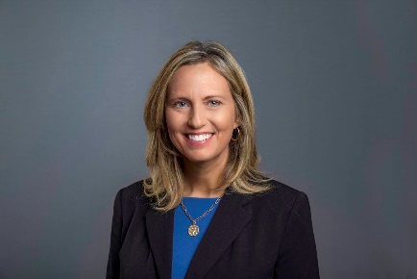
Kathy Harper Pam Thomas

