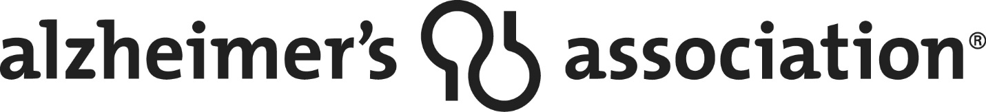

ALZHEIMER’S LICENSE PLATE
SIGN UP TODAY!
The Alzheimer’s Association has received approval from the State of Kansas for an Alzheimer’s specialty license plate for Alzheimer’s disease awareness in Kansas.
Once we collect 500 applications from interested individuals, the state will issue the plates. Please help us meet this goal as soon as possible!
It’s easy!
- Fill out the application form and submit a check for $30.00 made out to the Alzheimer’s Association – Heart of America Chapter and send to: Alzheimer’s Association 3846 W. 75th Street, Prairie Village, KS 66208. If we do not collect 500 applications, the fee will be returned to you or you can designate it as a donation to the Alzheimer’s Association.
- Once the 500 commitments are secured, the Alzheimer’s Association will send you a certification statement for you to provide to your county treasurer’s office when the plates are available. This certification will let them know that you have paid the required $30.00 royalty fee.

Design Not Final
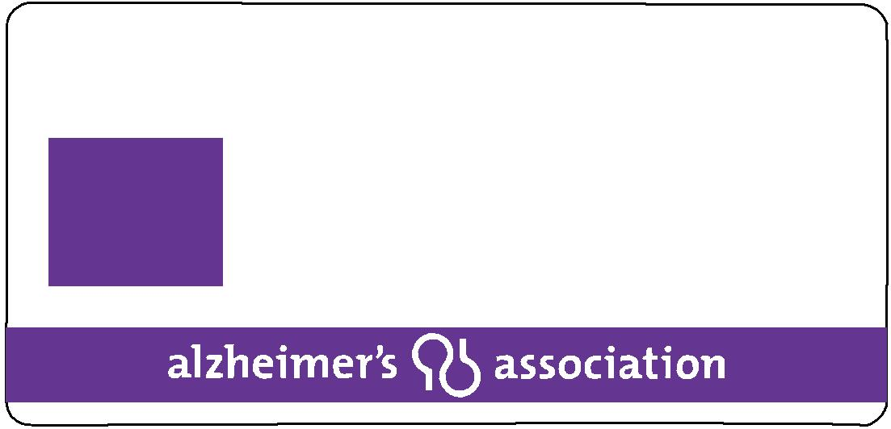
KANSAS

END
ALZ
0 0 0 0

Application for a Special License Plate
Please Print or Type:
INDIVIDUAL APPLICATION:
Name:_________________________________________________________________________
Address:_______________________________________________________________________
City:_____________________________ County:____________________ Zip:_______________
Email_________________________________________________________________________
Phone(s):______________________________________________________________________
_____ I would like my Certification statement emailed to me.
_____ I would like my Certification statement mailed to me.
I am applying for the following special license plate:
Alzheimer’s Disease Awareness
ORGANIZATION OR GROUP APPLICATION:
Name: Alzheimer’s Association – Heart of America Chapter
Address: 3856 W. 75th Street
City: Prairie Village State: KS Zip: 66208 County: Johnson

Donation Option:
If 500 applications are not collected to meet the minimum required by the state for issuance of a specialty Alzheimer’s license plate, you may have the option to designate your $30.00 fee as a general donation to the Alzheimer’s Association for the Alzheimer’s disease awareness in Kansas. You will receive an acknowledgement if this occurs.
______Yes, I wish to make this a $30.00 donation to the Alzheimer’s Association if the campaign to collect 500 Alzheimer’s specialty plate applications is not successful.
______No, please return my deposit if the campaign to collect 500 Alzheimer’s specialty place applications is not successful.

Signature:_____________________________________________________________
Date:__________________________

