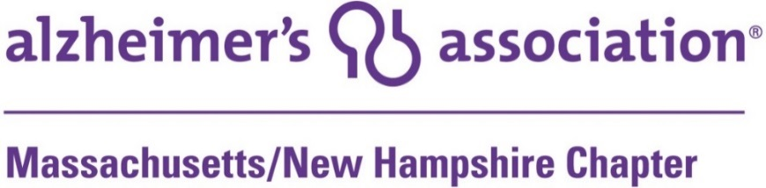

Early Stage Social Engagement Internship
Alzheimer’s Association, Massachusetts/New Hampshire Chapter
Unpaid, 10-15 Hours/Week
This internship is available in our Waltham, MA office

OVERVIEW
Founded in 1980, the mission of the Alzheimer’s Association is to eliminate Alzheimer’s disease through the advancement of research; to provide and enhance care and support for all affected; and to reduce the risk of dementia through the promotion of brain health.

The Massachusetts/New Hampshire Chapter operates out of its main office in Waltham, with regional offices in Springfield, Worcester, and Raynham, MA, and in Bedford, NH.

RESPONSIBILITIES
The Early Stage Engagement intern will plan, implement and assure positive experiences during social engagement events/activities for people living with memory loss and their care partners.
Reporting to the Manager of Early Stage Engagement, this intern will:
- Consult with staff to schedule early stage engagement activities, secure event logistics, assure group safety, and coordinate volunteers to provide hospitality.
- At social engagement events, provide hospitality and support needed to attendees by working with additional volunteers to provide a positive experience for ES groups.
- Responsible for the management of early stage event attendance statistics & rosters.
- Collect, distribute, and manage additional materials & literature needed by early stage attendees at events.
- Provide feedback on transition/termination of group members, participation in ongoing training and record keeping.
- Connect members of the community with additional Association services by proactively making referrals to Alzheimer's Association programs & free 24/7 Helpline.

QUALIFICATIONS
- Demonstrated success in working independently and with a team.
- Organized with a strong attention to detail.
- Successful in engaging people with dementia.
- Ability to create and maintain a safe environment where participants’ thoughts and feelings are valued and group members are treated with fairness, equity and respect.
- Commitment to promote the mission and services of the Association and willingness to act as an extension of the Association.
- Excellent verbal and written communications skills.

To apply, please email cover letter and resume to:
Christine Brown at volunteersmanh@alz.org

